

SIMATS ENGINEERING

Saveetha Institute of Medical and Technical Sciences
Chennai- 602105

Student Name: K. Hasini Reg. No.:192424181
Course Code: DSA0216 Slot: B
Course Name: Computer Vision with OpenCV for Modern AI
Course Faculty: Dr. Senthilvadivu S and Dr. T. Kumaragurubaran
Project Title: AI Mirror for Real-Time Posture Correction Using Computer Vision
Module Photographs:
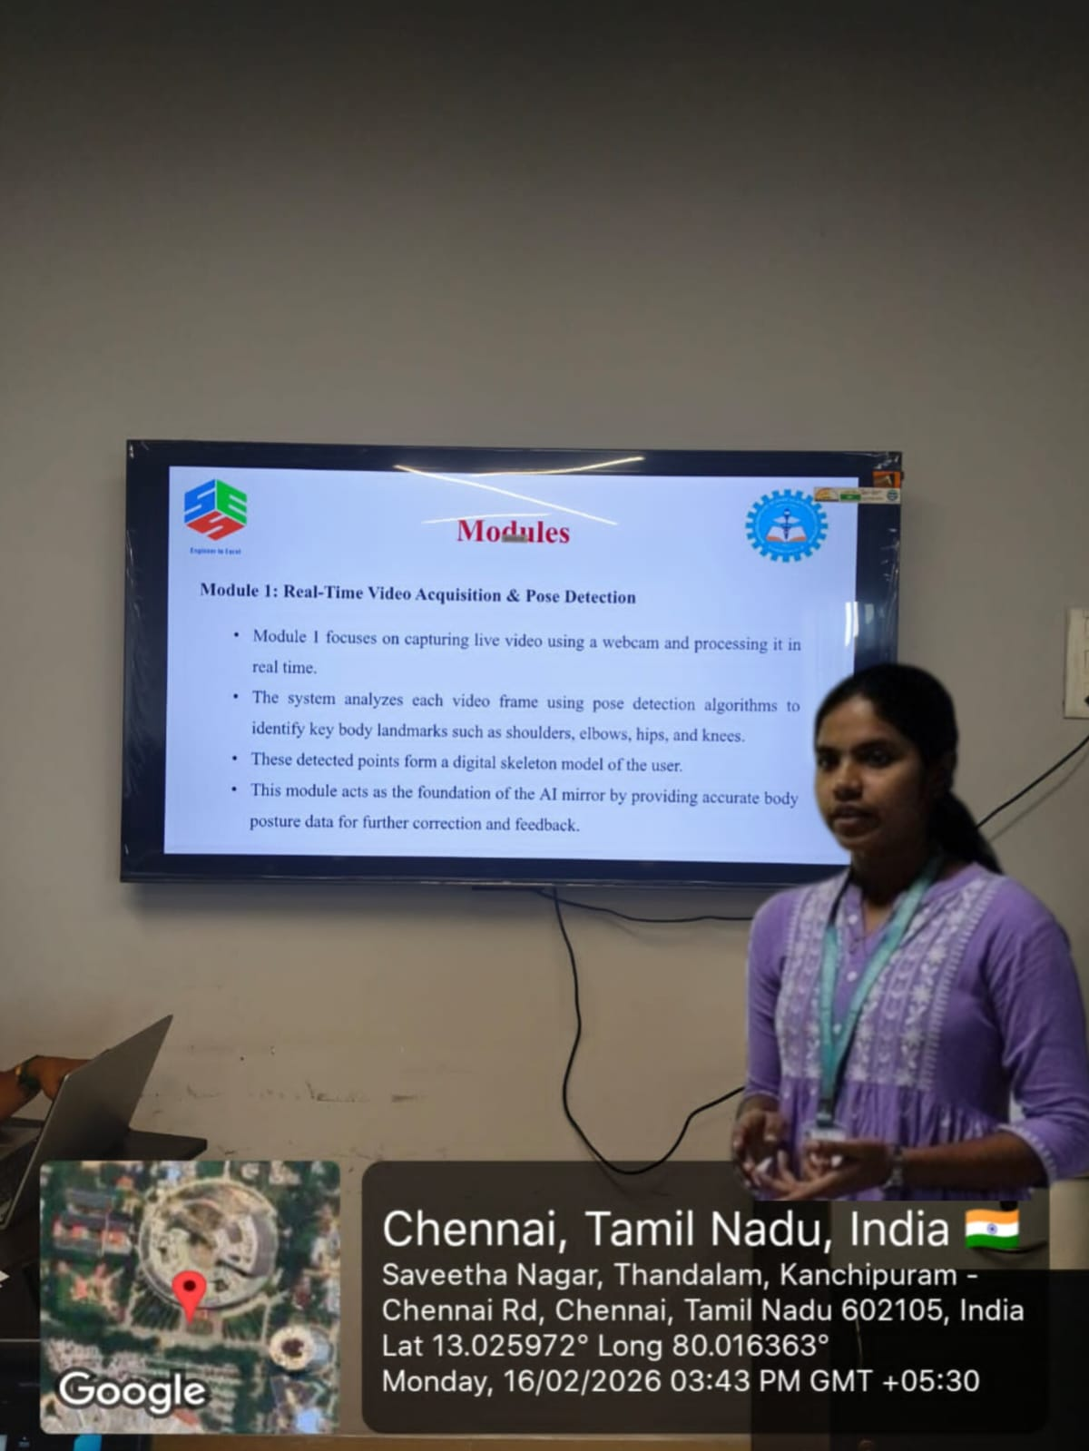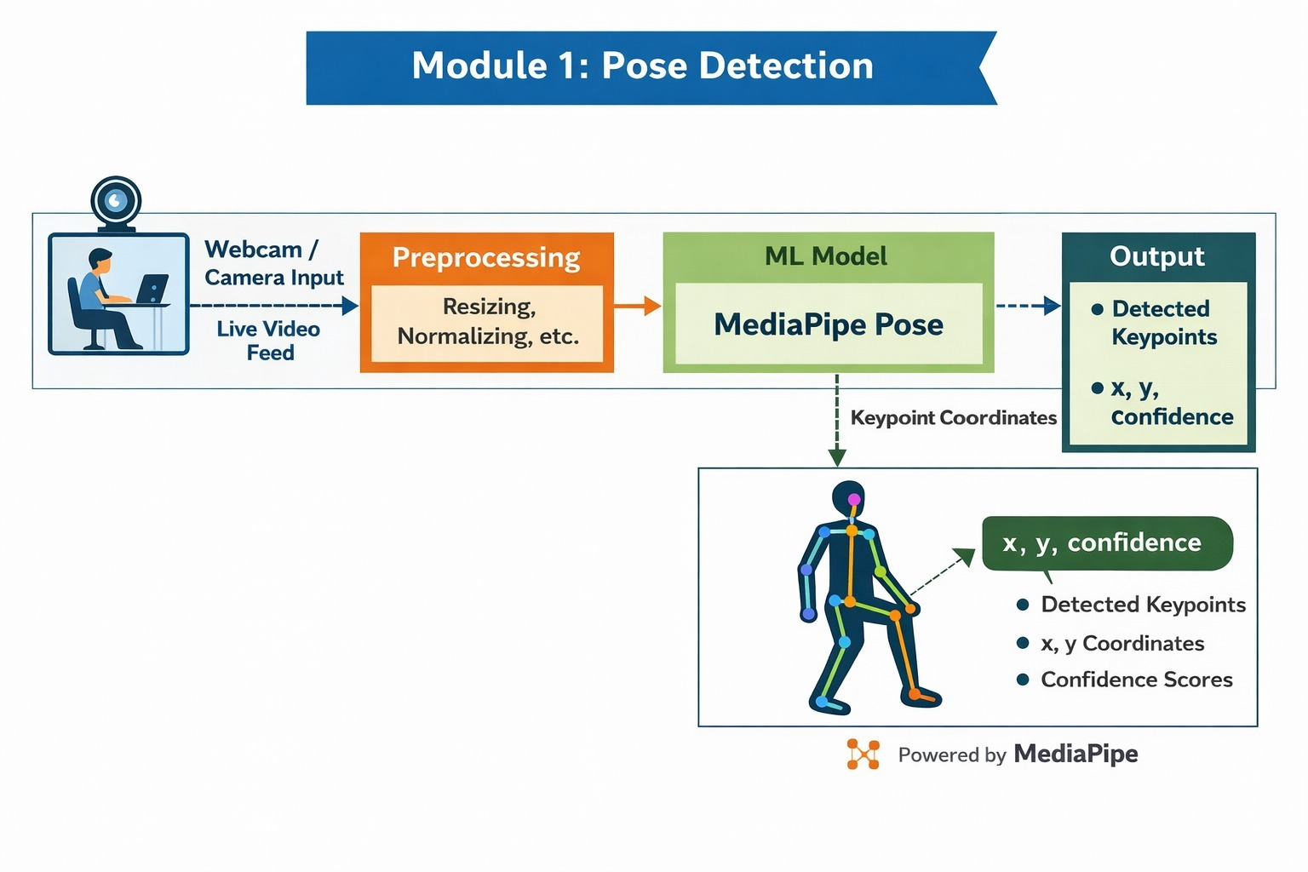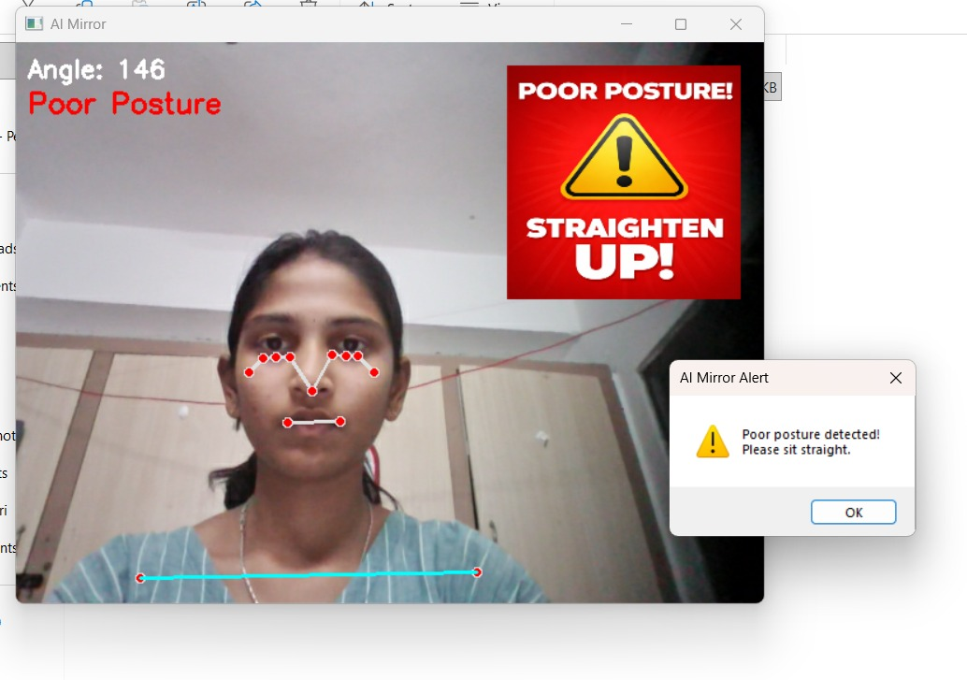
Project Description: (here you write what you did in this project (contribution) including Model Description
This project focuses on the design and implementation of an AI Mirror for Real-Time Posture Correction using Computer Vision to provide an intelligent, automated solution for monitoring and improving human posture during daily activities. My contribution included designing the system workflow, selecting suitable computer vision technologies, and developing modules capable of detecting posture deviations in real time. The system is structured using a modular architecture consisting of Real-Time Video Acquisition & Pose Detection, Posture Analysis & Deviation Detection, and Alert & Feedback System.
The AI Mirror captures live video input through a webcam and applies pose estimation algorithms to detect key human body landmarks such as the head, shoulders, spine, and hips. These landmarks are used to construct a skeletal model of the user, allowing the system to calculate body alignment and joint angles. By comparing these measurements with predefined ergonomic posture standards, the system identifies incorrect posture patterns such as slouching or forward head positioning. This automated analysis reduces the need for manual supervision and enables continuous posture monitoring.
For user interaction and health awareness, a real-time feedback mechanism was implemented to provide visual alerts whenever posture deviations are detected. The system displays corrective guidance directly on the screen, helping users immediately adjust their posture and develop healthier habits. By combining artificial intelligence, computer vision, and real-time processing.

Student Signature Guide Signature

